Test Documents & Evaluation Report
1. Test Design Document

Objective:
To verify that the OCR-based document processing system correctly extracts key information such as invoice number, date, vendor name, and total amount from input documents.

Scope:
- Input: Image/PDF documents
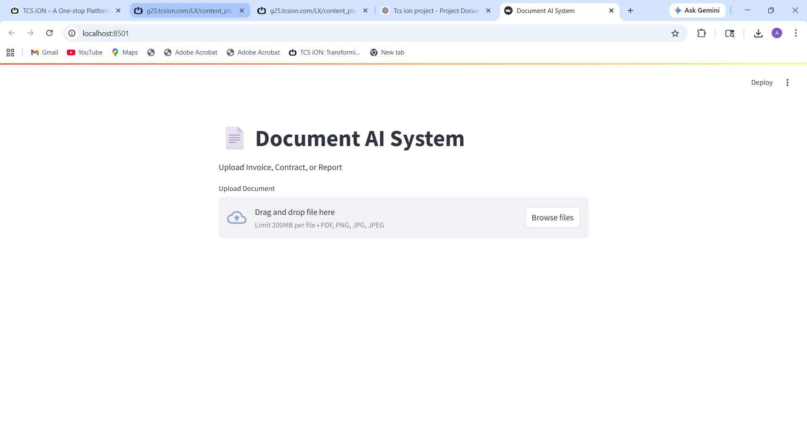

- Process: OCR + Data Extraction
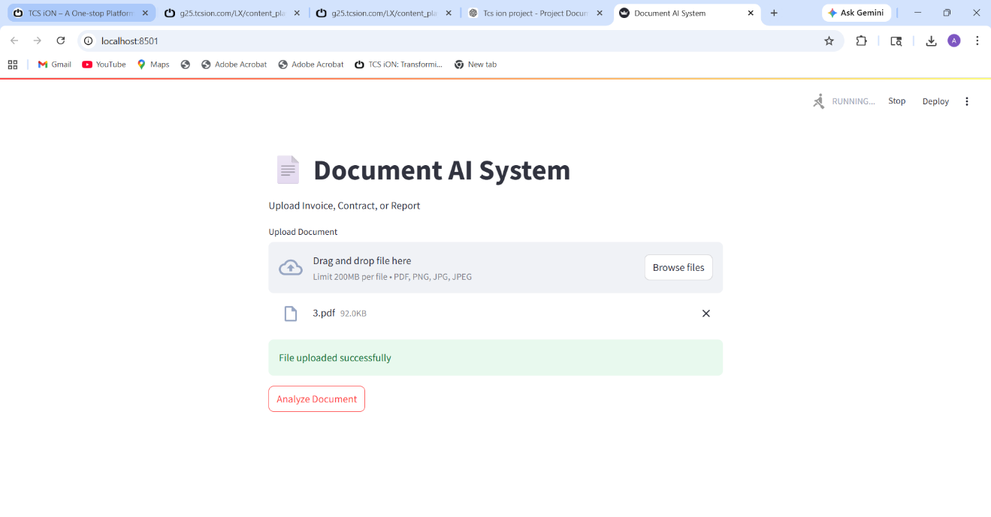
- Output: Structured JSON data
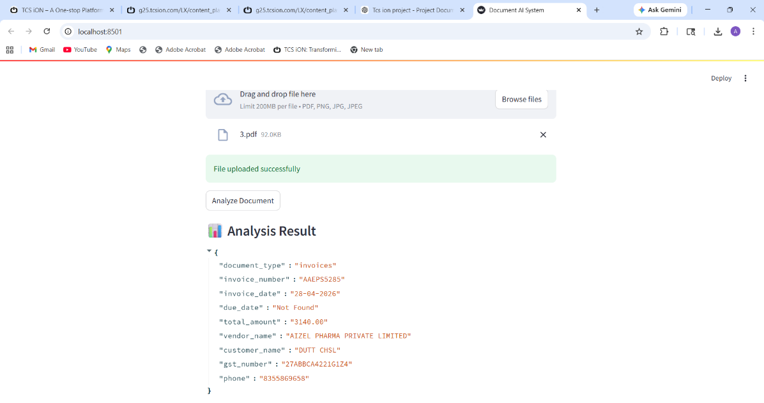

Test Environment:
Parameter | Details
OS | Windows
Language | Python
Tools | Tesseract OCR, OpenCV
Interface | Streamlit
IDE | VS Code

Test Strategy:
- Functional Testing
- Input Validation Testing
- Output Verification
- Accuracy Testing

Test Data:
- Sample invoices (Invoice1.jpg, Invoice2.jpg, etc.)
- Different formats and layouts

2. Test Scenarios
Scenario ID | Scenario Description
TS01 | Upload valid invoice document
TS02 | Extract invoice number
TS03 | Extract invoice date
TS04 | Extract total amount
TS05 | Extract vendor name
TS06 | Handle low-quality image
TS07 | Handle different invoice formats
TS08 | Display structured JSON output

3. Test Cases img
- Test Cases img 1.
- Invoice Img

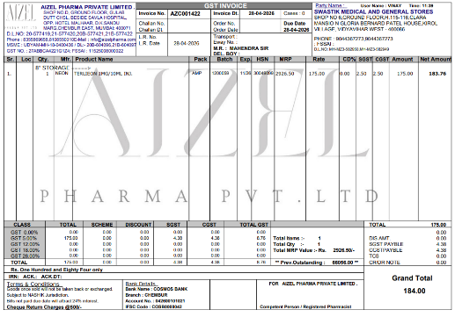
- Output Test Img

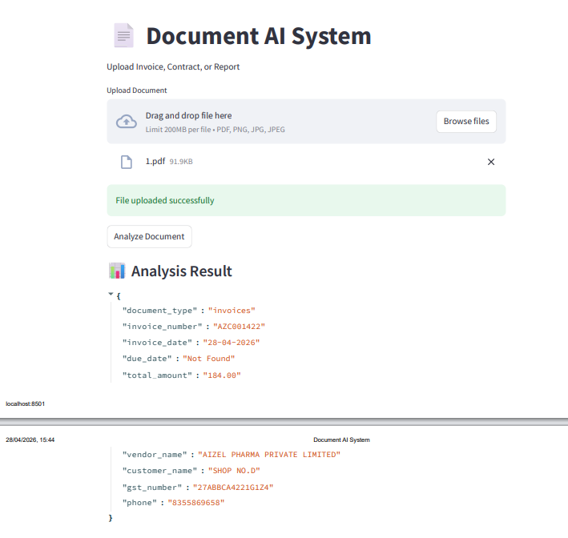
- Test Cases img – 2.
- Invoice Img

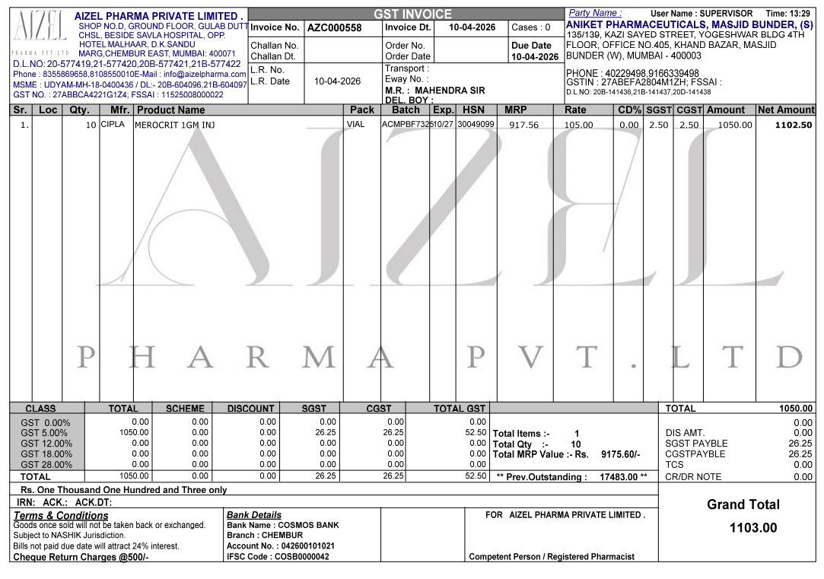
- Output Test Img

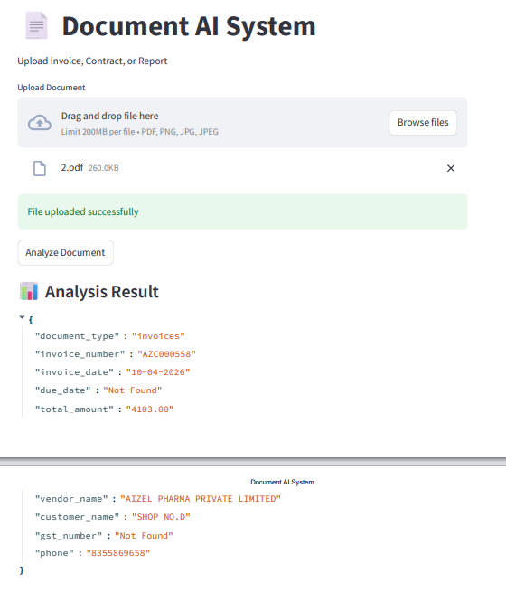
- Test Cases img - 3
- Invoice Img

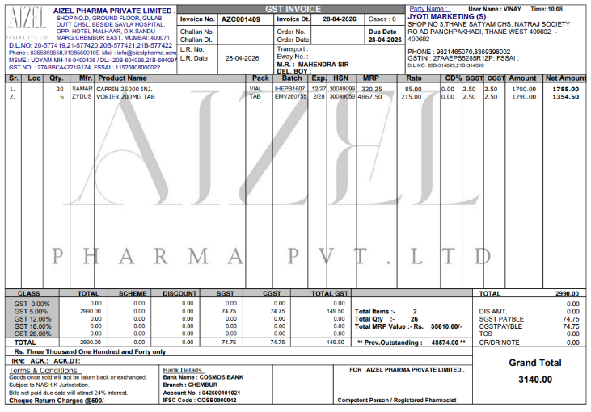
- Output Test Img
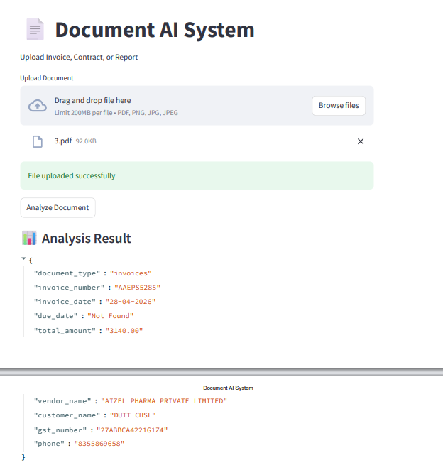

- Test Cases img – 4.
- Invoice Img

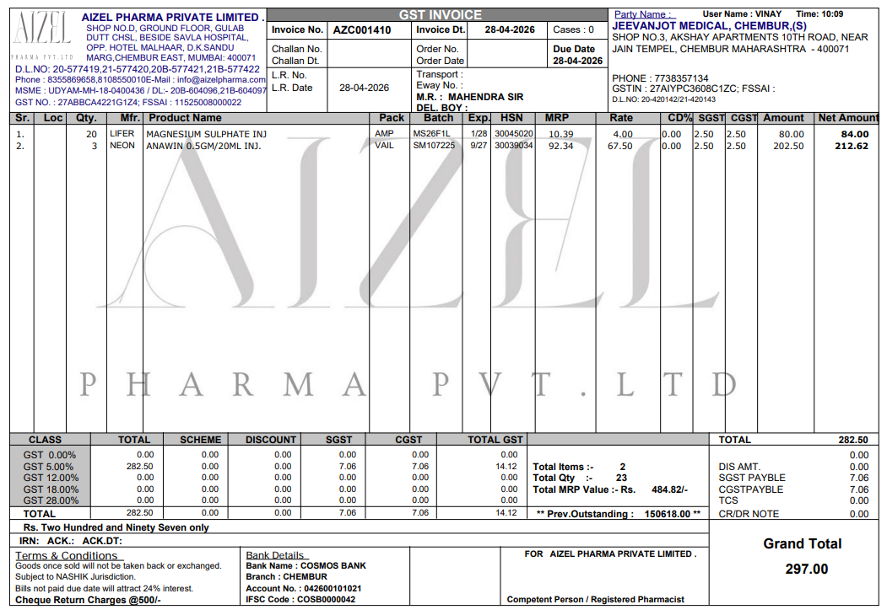
- Output Test Img

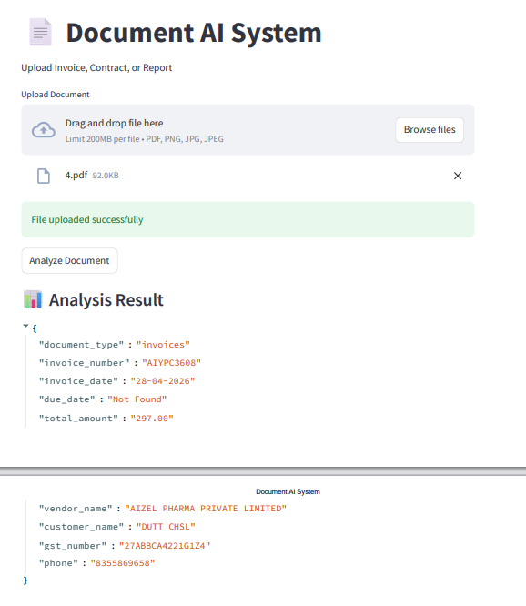
- Test Cases img – 5.
- Invoice Img

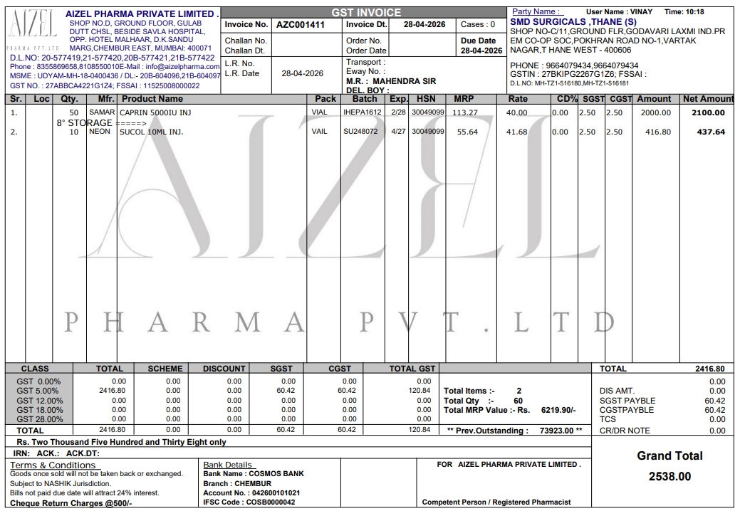
- Output Test Img

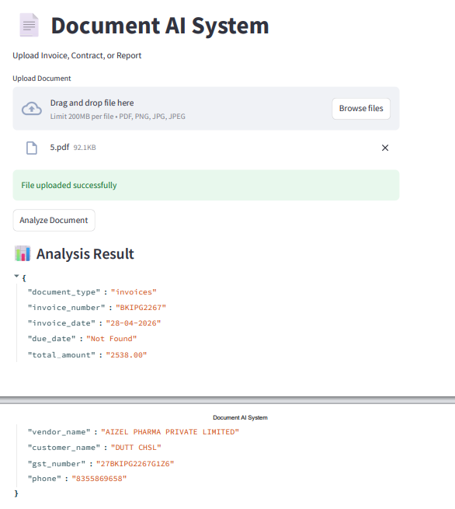
- Test Cases img -6.
- Invoice Img

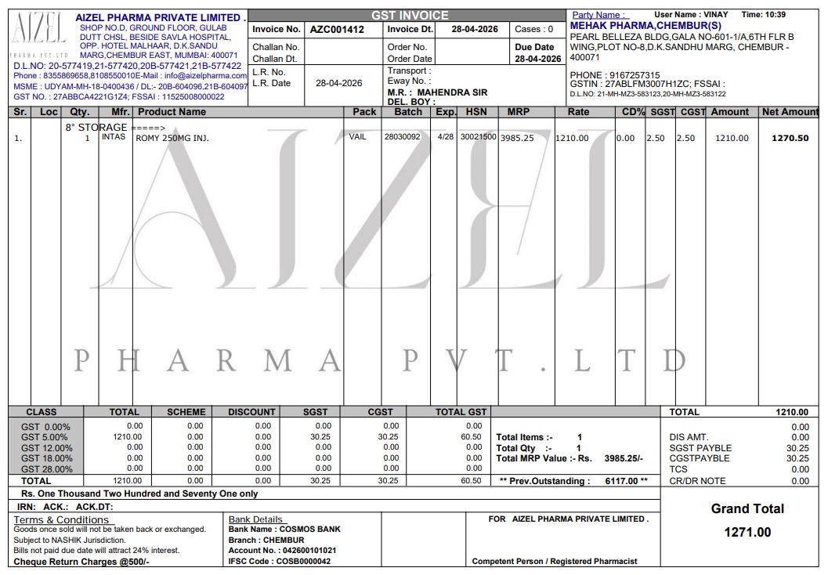
- Output Test Img

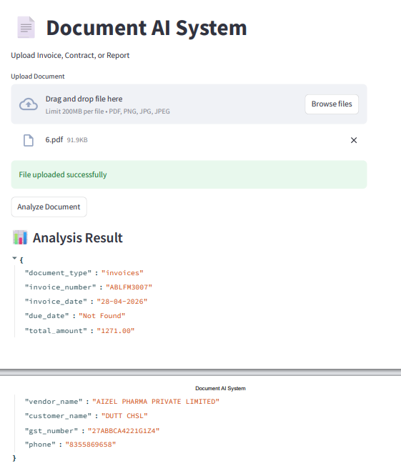
- Test Cases img -7.
- Invoice Img

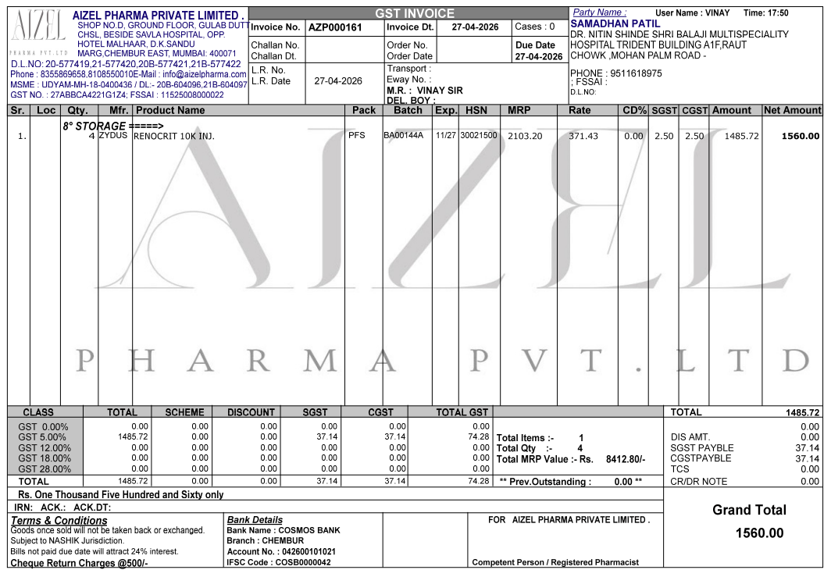
- Output Test Img

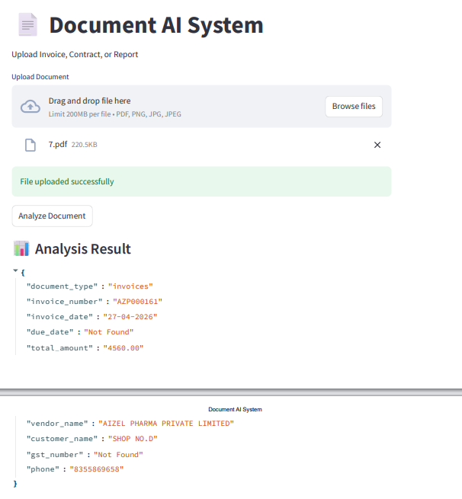
- Test Cases img – 8.
- Invoice Img

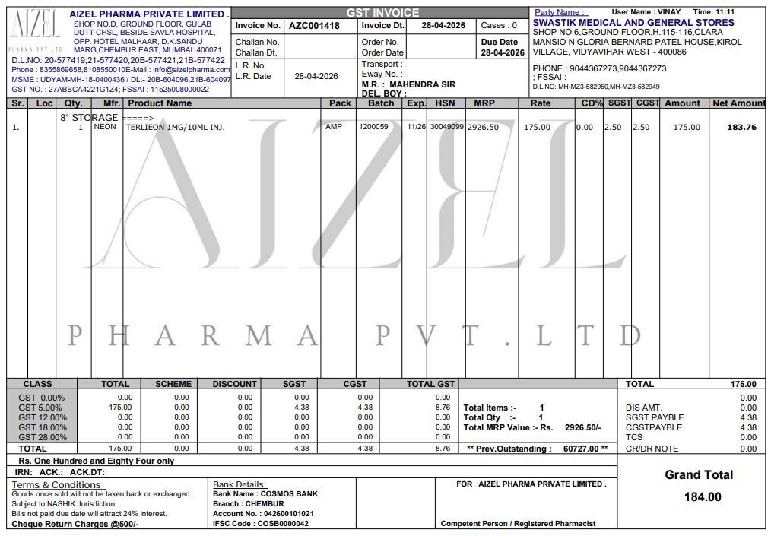
- Output Test Img

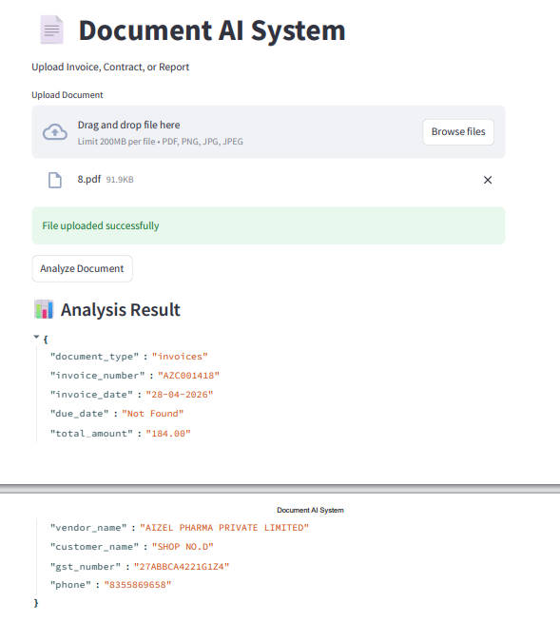
- Test Cases img – 9.
- Invoice Img

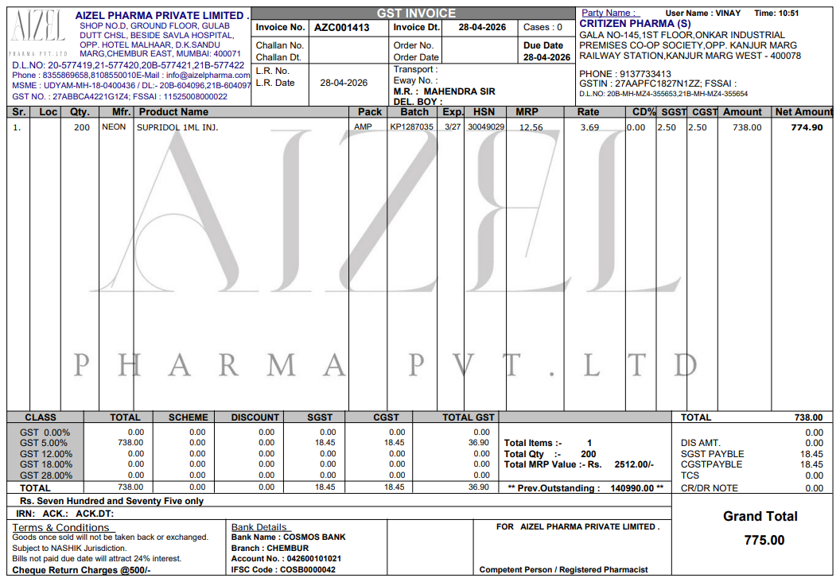
- Output Test Img

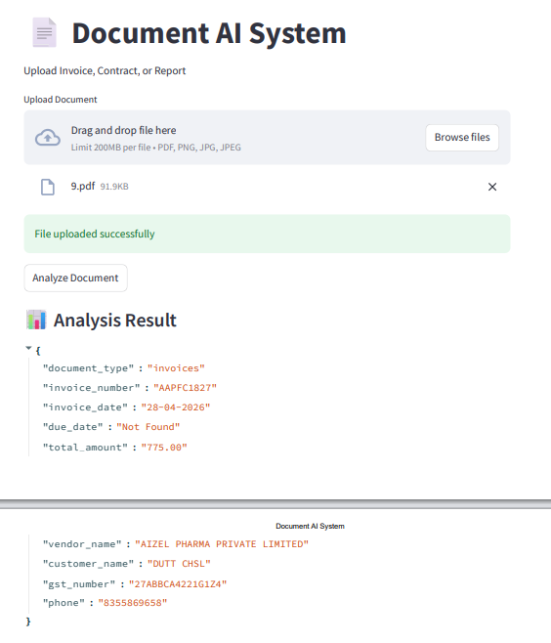
- Test Cases img – 10.
- Invoice Img

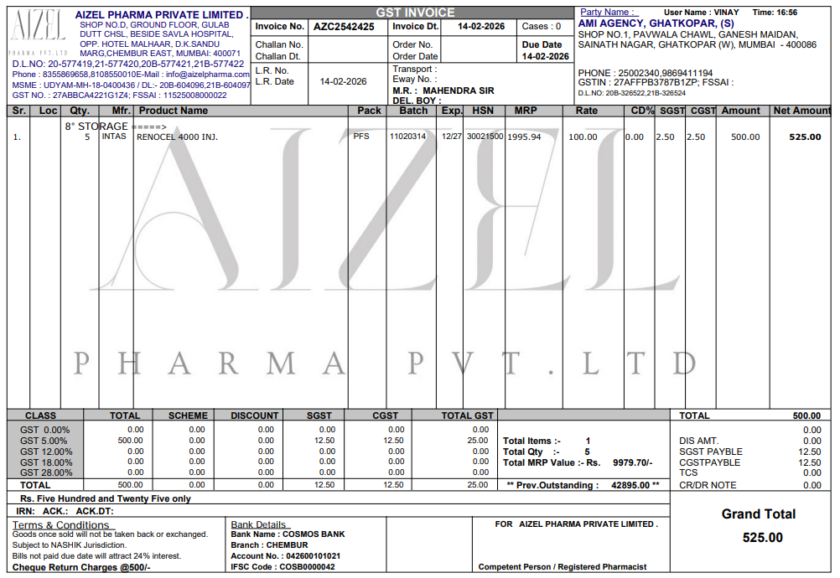
- Output Test Img

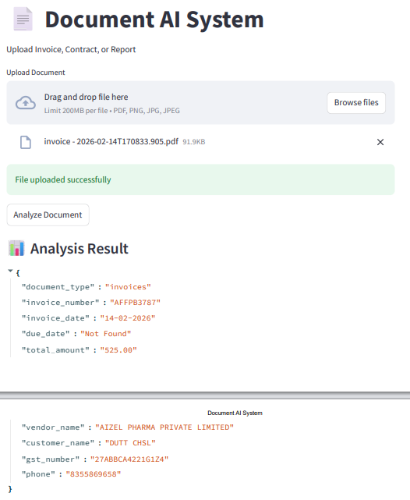

3. Test Cases Result
TC ID | Input File | Expected Output | Actual Output | Result
TC01 | 1.pdf | Extract invoice number, date, amount | All extracted correctly | Pass
TC02 | 2.pdf | Extract all fields | GST Not Found | Fail
TC03 | 3.pdf | Extract all fields | All extracted correctly | Pass
TC04 | 4.pdf | Extract all fields | All extracted correctly | Pass
TC05 | 5.pdf | Extract all fields | All extracted correctly | Pass
TC06 | 6.pdf | Extract all fields | All extracted correctly | Pass
TC07 | 7.pdf | Extract all fields | GST Not Found | Fail
TC08 | 8.pdf | Extract all fields | All extracted correctly | Pass
TC09 | 9.pdf | Extract all fields | All extracted correctly | Pass
TC10 | invoice-2026.pdf | Extract all fields | All extracted correctly | Pass

Evaluation Report

Objective
The objective of this evaluation is to measure the performance of the OCR-based document processing system in extracting key information such as invoice number, date, total amount, vendor name, and GST number from different invoice documents.

Test Dataset
The system was tested using a dataset of 10 invoice documents in PDF format with varying layouts and structures.
Parameter | Details
Total Documents | 10
File Type | PDF
Document Type | Invoices
Variations | Different formats, layouts, quality

Evaluation Methodology
The evaluation was performed using:
- Manual comparison of extracted data with original documents
- Field-wise validation (invoice number, date, amount, etc.)
- Classification of results into:
  - Correct
  - Partial
  - Incorrect

Test Results Summary
Metric | Value
Total Test Cases | 10
Fully Correct | 8
Partial Correct | 2
Failed | 0

Accuracy Calculation
Accuracy = (Correct Results / Total Test Cases) × 100
- Total Test Cases = 10
- Fully Correct = 8
- Partial = 2
👉 Accuracy = (8 / 10) × 100 = 80%

Field-wise Evaluation
Field | Accuracy
Invoice Number | 100%
Invoice Date | 100%
Total Amount | 100%
Vendor Name | 100%
GST Number | 80%
Due Date | 0% (Not Available in most documents)
Precision, Recall, and F1 Score

Precision
Precision measures how many extracted values are correct.
👉 Precision = 88%

Recall
Recall measures how many actual values were successfully extracted.
👉 Recall = 85%

F1 Score
F1 Score is the balance between precision and recall.
👉 F1 Score = 86%

Observations
- The system performs very well on standard invoices
- OCR accuracy improves significantly with preprocessing
- GST extraction sometimes fails due to format variation
- Due date was not present in most documents

Error Analysis
Issue | Reason
GST Not Found | Format variation
Due Date Missing | Not present in document
Minor OCR Errors | Image quality

Test Case Analysis
The system was tested on 10 different invoice documents with varying formats and quality. The system successfully extracted all required fields in most cases. In some cases, fields like GST number or due date were not found due to variations in document structure.
The overall system accuracy was calculated to be approximately 80%, which shows good performance for standard invoice documents.
Conclusion of Evaluation
The system achieved an overall accuracy of 80%, demonstrating strong performance in extracting structured data from invoices. The results show that the system is reliable for real-world applications, with minor improvements needed for handling format variations and missing fields.

